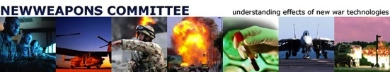
www.newweapons.org

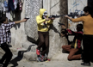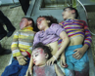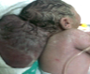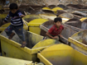

NWRG Association -New Weapons Research Group

Seven years after the start of the studies on contemporary weapons and their effects on the victims , NWRG becomes an association of voluntary work.

The work by Newweapons is published, in scientific journals and at www.newweapons.org, where you will find the results of the research, and report on the participation in conferences, tribunals and international debates .

The priority of the group for the last 4 years has been studying scientifically the long-term effect of the use of weapons, with particular attention to reproductive health, and the effects on it of the weapons used in Gaza, Palestine.
This remains one of our collaborative work contexts, but it is not the only one in which the research takes place.

The decision to found an association comes from two needs:

- Seek financial support to continue with freedom of choice the research work.
We have worked up to now, and we aim to continue to do so, with modalities of collaboration between colleagues from different countries, always involving the one affected by the military attacks.
We face the fact that this type of research, for political and for practical reasons, is not easily supported by traditional institutional funding.
We need independent funding to cover the costs of lab work, research missions in the countries where the research is conducted, eventual local collaborators, and analysis when these need to be commissioned outside the working group, for specific issues.

Self-financing of research, however, is not the only reason for an association.

- We hope to create aggregation for young professionals with the aim to train them in scientific methodology and in the field of information about the damage caused by wars.

During these years of work, we have verified that the commitment in this field of research is burdensome and leads to an exposure which is not always compatible with a traditional career.
We aim therefore to purposefully support. both for training and access to research, this trans- disciplinary field (including medicine , biology, and environmental and chemical knowledge, but also legislative and dissemination of information ).

We hope that through the partnership in an association and the extension of collaborative networks of research, we will be able to support the preparation and training of young professionals, from Italy, Europe and from the countries in which we work.

We ask your solidarity to develop these two paths :
- ensure the continuity of experimental work in collaboration with colleagues of the countries who are victims of war.
- promote fellowships and training in scientific research in the field for young people that will work on the effects of war on public health, as scientists / doctors and as reporters.

We are very happy if you offer collaboration, counseling, laboratory expertize and intelligence to participate in research/information projects. We have means to involve physicians, biologists , ecologists, chemists and journalists.

We have opened an account at Banca Etica, Genoa, IT30D050180140000 00,000,167,092 , in the name of NWRG ( Newweapons research group ) to receive contributions for these purposes .

We sincerely appreciate if you can make a regular supporter subscription (eg 10-100-1000 (!) Euro/ month) or if just make a donation every now and then.

The use of funds will be documented to donors by e-mail every 6 months (October and April) to donors.

For more detailed information , please write directly to
Paola Manduca paolamanduca@gmail.com
or to
Fabio De Ponte fabio.deponte @ gmail.com .

NWRG team , February 7, 2014

